PROGRAM FOR SETTER , GETTER , TOSTRING FUNCTION.TO FIND THE VOLUME OF THE CUBOID
Getters and Setters play an important role in retrieving and updating the value of a variable outside the encapsulating class. A setter updates the value of a variable, while a getter reads the value of a variable.
accessors are used to get the value of a private field and mutators are used to set the value of a private field.

A toString() is an in-built method in Java that returns the value given to it in string format.
The toString() method returns the String representation of the object.

Get the String representation of the object.

If you print any object, Java compiler internally invokes the toString() method on the object.

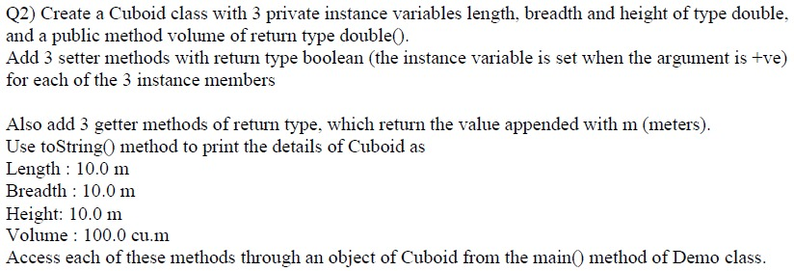

Cuboid.java
package pack1;
public class Cuboid
{
private double l,b,h;
public boolean setL(int len)
{
if(len>0)
{
l=len;
return true;
}
return false;
}

public boolean setB(int bre)
{
if(bre>0)
{
b=bre;
return true;
}
return false;
}

public boolean setH(int hei)
{
if(hei>0)
{
h=hei;
return true;
}
return false;
}

public String getL( )
{
return l + " m";
}

public String getB( )
{
return b + " m";
}

public String getH( )
{
return h + " m";
}

public double volume( )
{
return l*b*h;
}

public String toString( )
{
String str = String.format("Length :%s%nBreadth :%s%nHeight :%s%nVolume :%f Cu.m", getL( ),
getB( ),getH( ),volume( ));

return str;
}

}

CuboidDemo.java
package pack1;
public class CuboidDemo
{
public static void main(String[] args)
{
Cuboid cu = new Cuboid( );
if(cu.setL(10) && cu.setB(10) && cu.setH(10))
{
System.out.println(cu);
}
else
{
System.out.println("Enter valid input");
}

}

}

